Hammton | AI & Automation Developer

Selected Projects
Solar E-Commerce Website + Intelligent AI Sales Chatbot (Billson Solar)
Website:billsonsolar.com
Stack: Custom web dev, AI chatbot, e-commerce automation, API integrations

Overview: Built a full solar e-commerce platform and integrated an advanced AI assistant capable of guiding customers through the entire buying journey. Highlights:
- Conversational product discovery (recommends solar systems based on user needs)
- AI-powered budgeting system generating accurate solar setups
- Cart automation (bot adds items to cart directly)
- Page navigation via chat commands ("take me to batteries", "show me inverters")
- Works as an interactive sales agent increasing conversions and reducing support time

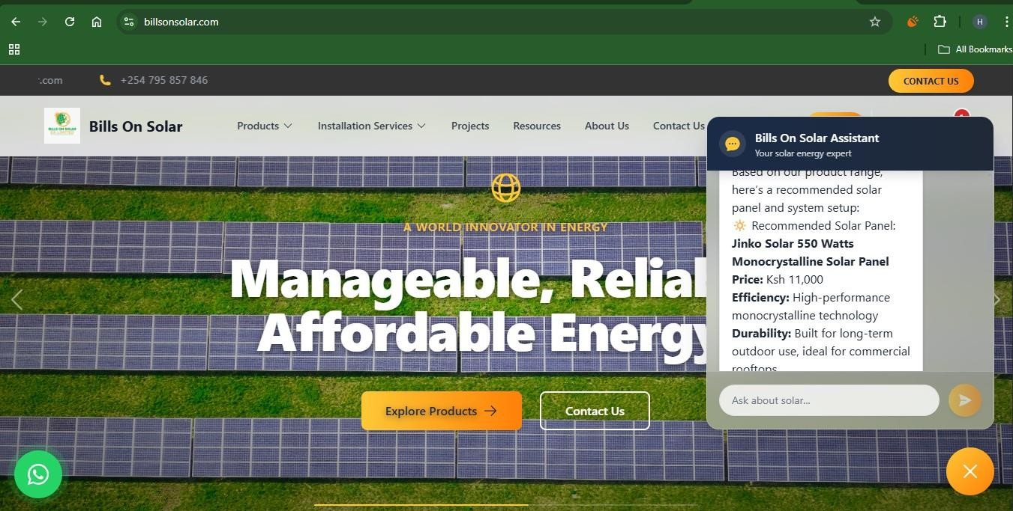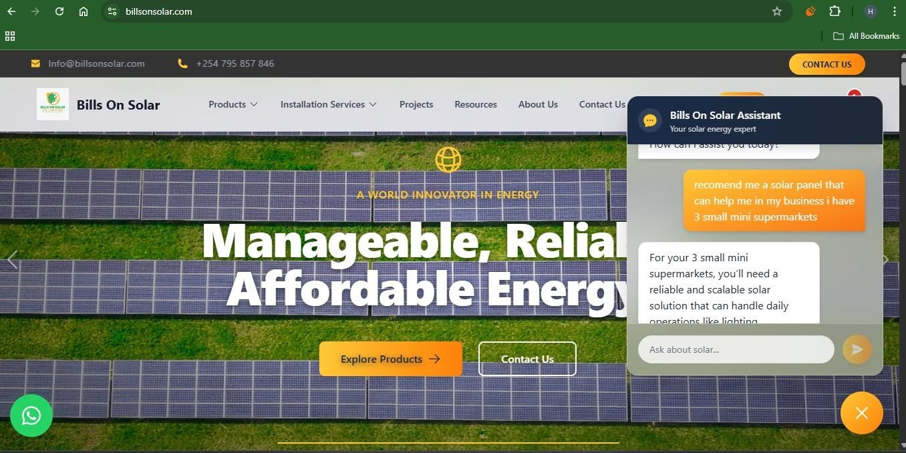

WhatsApp AI Chatbot (Evolution API – non-Meta route)
Evolution:. API Node.js, AI API stack(OpenAI/Gemini), custom logic

Overview: Built a full WhatsApp AI chatbot without using Meta’s official API, enabling faster deployment and more flexible automation. Highlights:
- Natural-language interactions
- Product recommendations, Q&A, and guided workflows
- Can integrate with web systems, CRMs, and automation pipelines
- Built-in fallback logic and safety prompts

Highlighted Projects
1. Personal Brand Automation Workflow
Stack: n8n, OpenAI API, Airtable, Webhooks
Purpose: Automates personal branding content (LinkedIn posts, headshots, bios).
Key Features:
- Dynamic routing by service selection (headshots, posts, or both).
- Image processing via custom code nodes (base64 handling and Gemini API prep).
- LinkedIn content generation with AI using user profile data.
- Error handling and data normalization for consistent output.
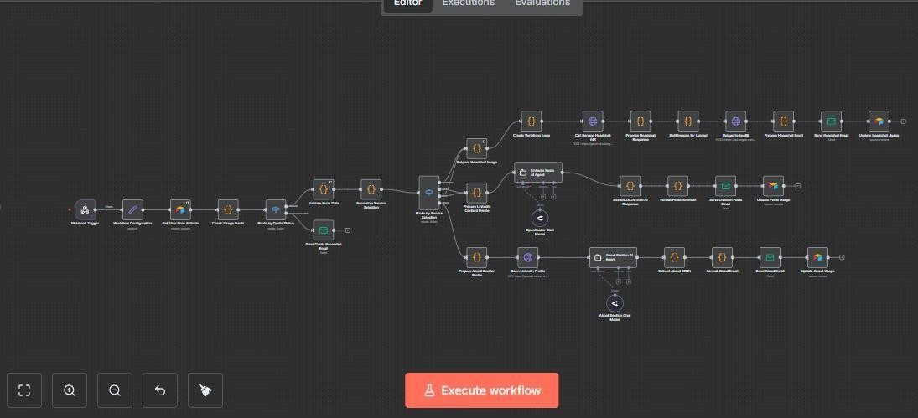
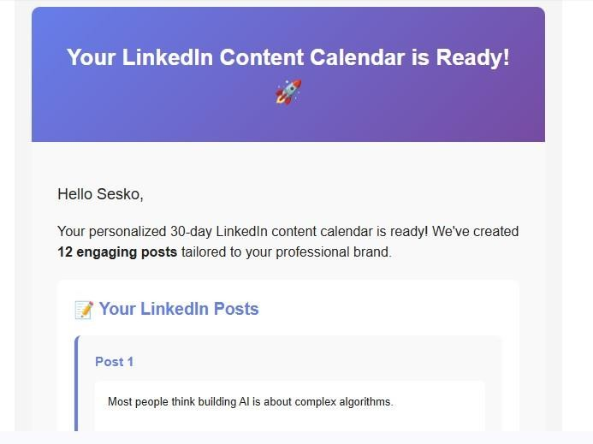

2. LinkedIn Banner Generation with Webhook Validation & Usage Tracking
Stack: n8n, Airtable, Imgbb, OpenRouter API
Purpose: Automates personalized LinkedIn banner generation with monthly usage tracking. Key Features:
- Webhook input validation for user requests.
- Airtable integration for tracking banner counts and subscription limits.
- AI-driven banner creation pipeline via Gemini API.
- Automated updates to Airtable and status notifications
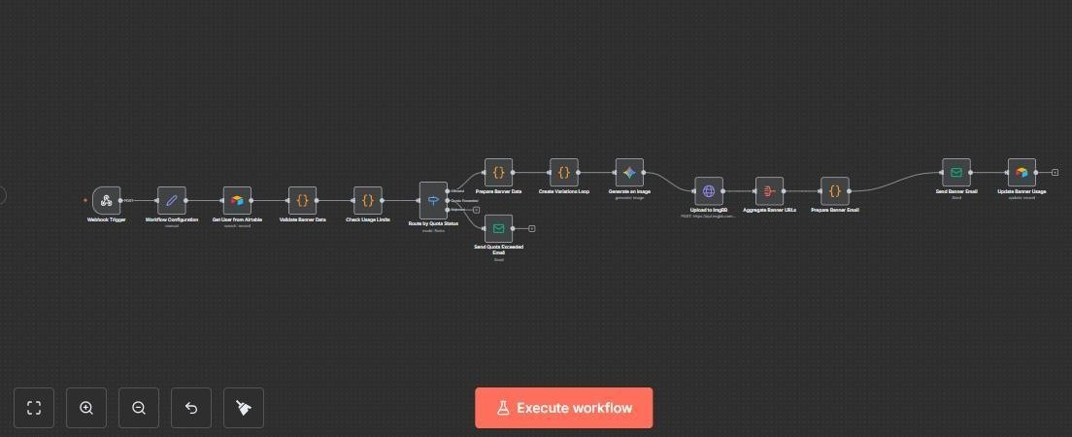

3. Lead Gen Subscriber AI Agent
Stack: n8n, Airtable, HTTP Requests, OpenRouter API
Purpose: Captures, validates, and enriches leads for AI marketing funnels.
Key Features:
- Webform data capture and cleaning.
- Duplicate checking via Airtable lookup.
- AI-powered enrichment: trends, insights, and custom responses.
- Automatic follow-up updates and CRM integration.
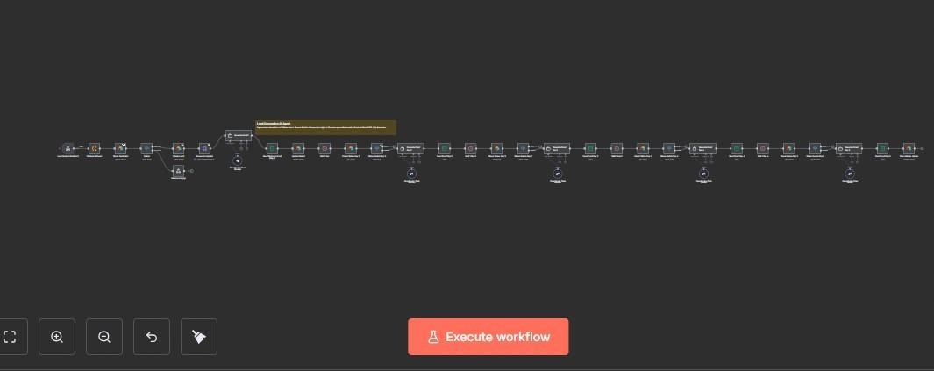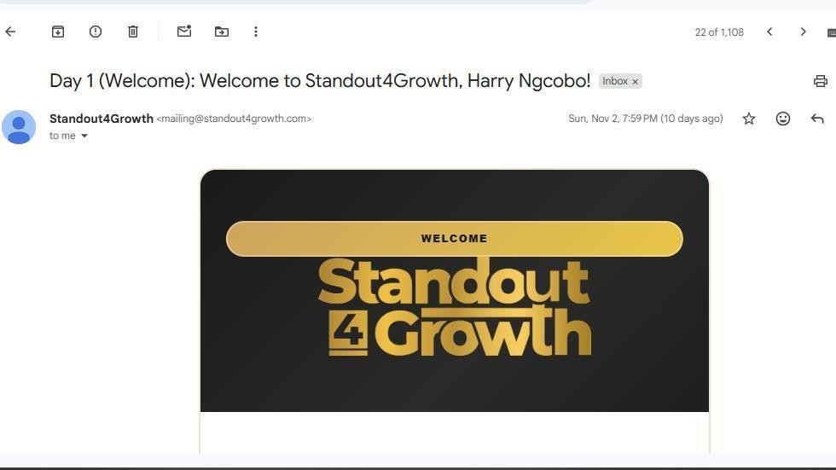

4. Cal.com Invitee AI Agent
Stack: n8n, Airtable, Cal.com Webhooks
Purpose: Manages booking automations, invitee data, and meeting details.
Key Features:
- Extracts and stores invitee information in Airtable.
- Tracks events, reschedule, and cancel URLs.
- Automates client notifications and reminders.
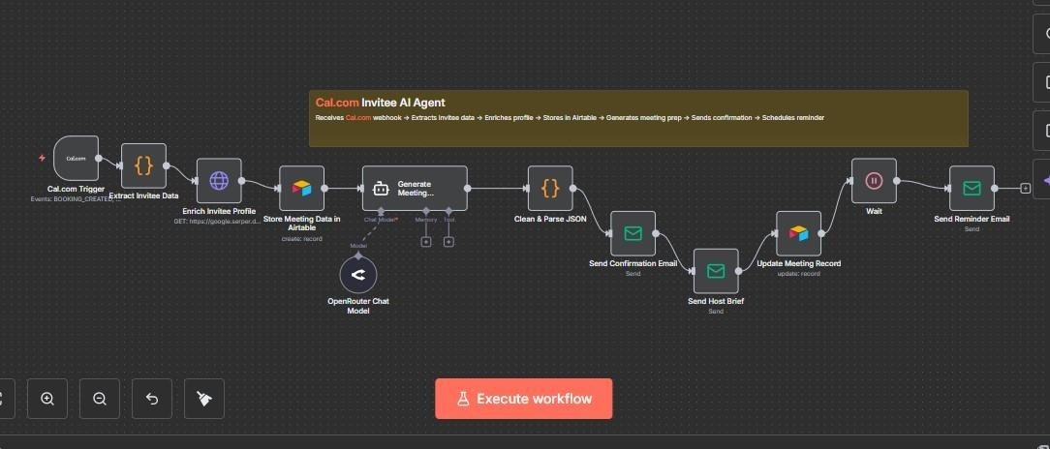

5. Standout4Growth AI Assessment
Stack: n8n, LangChain, OpenAI / Gemini
Purpose: AI-based personal branding self-assessment system.
Key Features:
- Webhook form capture and scoring logic.
- AI-generated personalized results using prompt templates.
- JSON-structured responses for seamless integration.
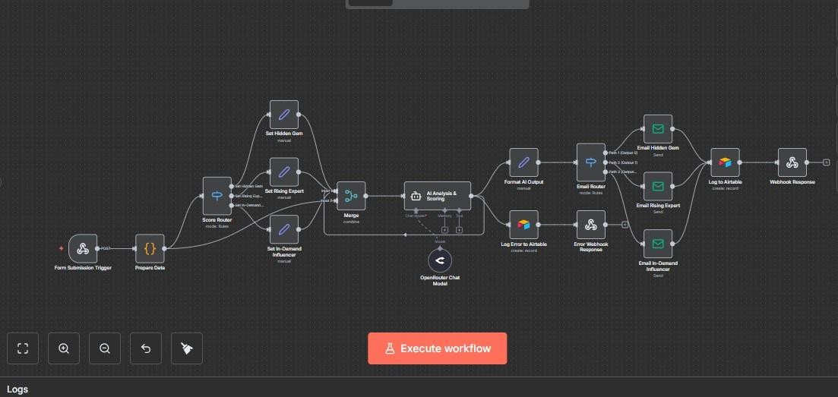

6. Standout4Growth AI Chatbot
Stack: n8n, Supabase, Gemini, LangChain
Purpose: Hybrid chatbot offering personal branding guidance and company Q&A.
Key Features:
- Dual AI context (brand coach + factual assistant).
- Supabase vector store retrieval for factual responses.
- Memory persistence for chat continuity.
- Integrated with Gemini 2.5 via OpenRouter.
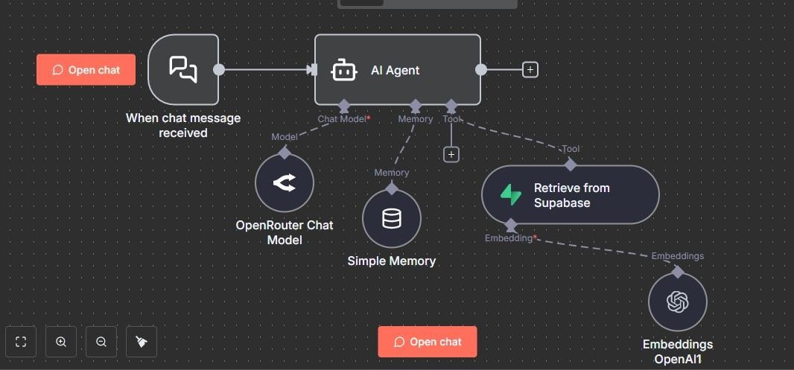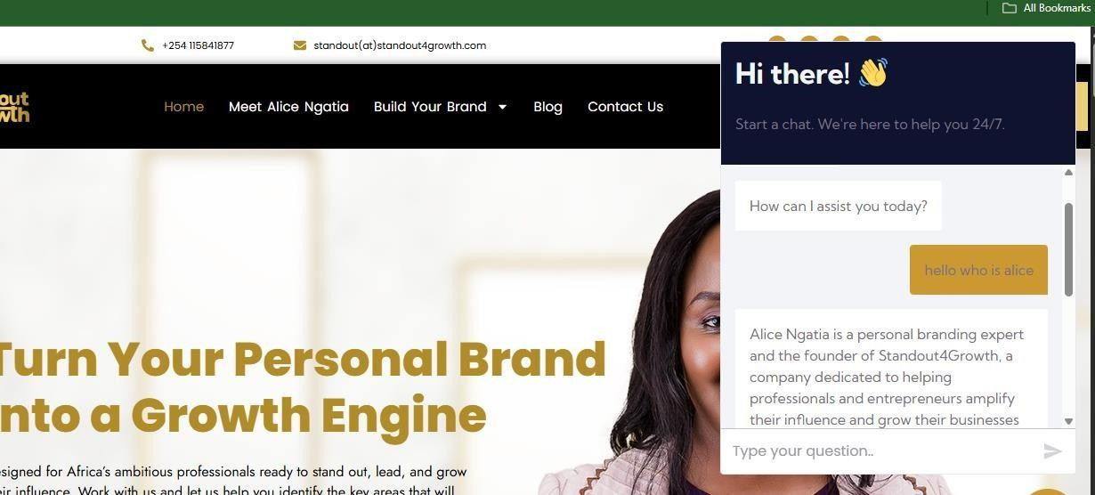

7. Product Image Enhancement Workflow
Stack: n8n, Gemini API, Imgbb, Webhooks
Purpose: Enhances product photos with AI (lighting, background, overlays).
Key Features:
- Input validation and smart enhancement logic.
- AI model-driven editing via Google nano-banana-edit model. - Dynamic prompts for overlays (price, brand).
Returns enhanced image directly via webhook
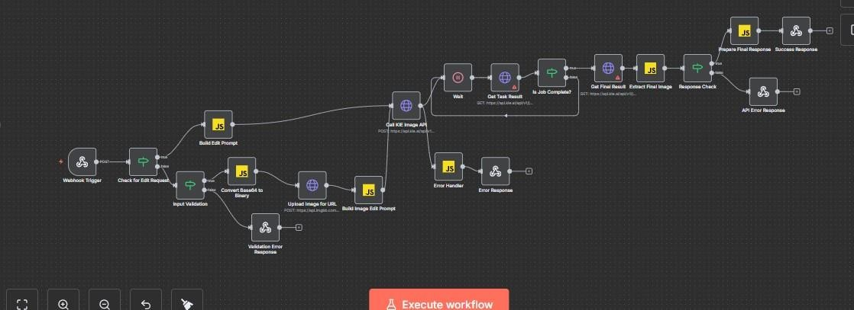

8. AI Color Advisor Agent Workflow
Stack: n8n, OpenRouter API, Gemini 2.5 Flash Image
Purpose: Generates professional color palettes from house images.
Key Features:
- Vision model analyzes uploaded images.
- Produces structured JSON with palettes and reasoning.
- Parses, validates, and formats recommendations dynamically. - Generates visual 3D previews for presentation.
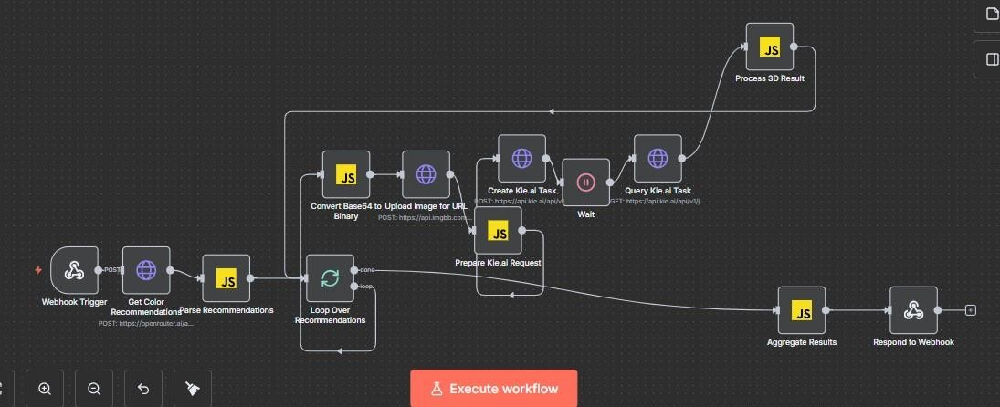

Core Technical Skills
  - Automation Platforms: n8n, Make (Integromat), Zapier
  - AI & LLMs: OpenAI, Gemini, LangChain, OpenRouter
  - Data & APIs: Airtable, Supabase, Notion, Google API Suite
  - Languages: JavaScript, Python (scripting & API handling)
  - Specialties: AI workflow design, webhook integration, prompt engineering, API orchestration, automation optimization

Automated Customer Onboarding Email System

Project Overview
An intelligent n8n workflow that automates personalized post-purchase email communications for Standout4Growth, a professional development and personal branding company. The system intelligently processes incoming purchase confirmation emails and automatically sends tailored onboarding messages based on the specific products purchased.

Business Challenge
Standout4Growth offers multiple coaching products and digital resources (Executive Coaching, Career Breakthrough Accelerator, 360° Personal Brand Survey, AI Branding Toolkit). Each product requires unique onboarding instructions, next steps, and customer engagement materials. Manual processing of purchase confirmations and sending personalized welcome emails was:
- Time-consuming and prone to human error
- Created delays in customer onboarding
- Risked inconsistent customer experience
- Limited scalability as the business grew

- 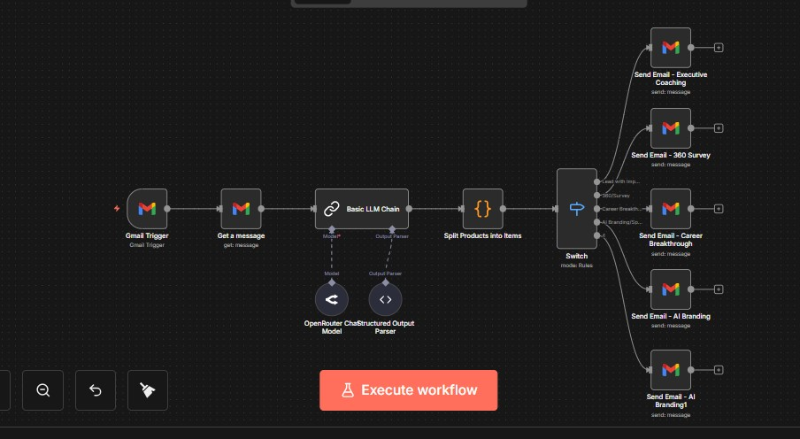

Contact
Email: ndekeharrison8@gmail.com
LinkedIn: https://www.linkedin.com/in/harrison-ndeke-168aa9263/

